

CHANDIGARH UNIVERSITY

Project on Designing THE FLEX of University fest

**Student Name: Pema Yangchen**

**UID: 23BCA10682**

**Branch: BCA Section/Group: 7B Semester: 3**

**Subject Name: Desktop Publishing**

**Subject Code: 23CAP-204**

Table of Contents

1. Overview of Adobe Photoshop

2. Objectives and Tasks

3. Adobe Photoshop Tools and Techniques Used

4. Design Process

* Open Photoshop
* Create New Document
* Use shape tool
* Use type tool
* Final design

5. Out Put

6. Learning Outcomes

7. Challenges Faced and Solutions

8. Conclusion and Future Enhancements

9. Evaluation Grid

1. Overview of Adobe Photoshop Adobe

Photoshop is one of the most widely used software applications for image editing, graphic design, and digital art. Originally developed by Thomas and John Knoll and first released in 1988, it has since evolved into a highly sophisticated tool used by professionals and enthusiasts alike across various industries, including photography, web design, advertising, and multimedia. Here’s an overview of its features, functionalities, and the impact it has had on the creative industry:

✓ Purpose and Uses

• Adobe Photoshop is primarily used for editing raster (bitmap) images, meaning it operates on pixels rather than vector data. Its main uses include:

• Photo Editing and Retouching: Photoshop allows users to enhance photographs by adjusting color, brightness, and contrast, as well as correcting blemishes and imperfections. • Graphic Design: Photoshop is equipped with tools to create digital artwork, posters, flyers, business cards, and other visual elements.

• Web and UI Design: Many web designers use Photoshop to create website mockups, wireframes, and elements for user interfaces.

• Digital Painting and Illustration: Artists use Photoshop's brushes and layering system to create digital paintings and illustrations.

• 3D Modeling and Texturing: Photoshop has a suite of 3D tools for creating and editing 3D models, adding texture, and integrating them into designs.

• Video Editing: Although it’s not primarily a video editor, Photoshop offers basic tools for video and animation editing.

❖ Tools of Adobe Photoshop

1. Selection Tools Selection tools allow users to isolate specific parts of an image to edit them separately.

• Move Tool: Used to move selected objects, layers, or parts of an image.

• Marquee Tools (Rectangle, Elliptical, Single Row, Single Column): Create rectangular, elliptical, or single-line selections.

• Lasso Tools:

* Lasso Tool: Draws freeform selection borders.
* Polygonal Lasso Tool: Creates straight-edge selections.
* Magnetic Lasso Tool: Clings to the edges of objects for precise selection.

• Quick Selection Tool: Selects areas based on color and texture similarity. Good for quickly selecting complex shapes.

• Magic Wand Tool: Selects pixels with a similar color. Useful for selecting backgrounds or single-colored areas.

1. Crop & Slice Tools These tools allow users to trim or slice images and prepare them for export or web use.

• Crop Tool: Crops images to remove unwanted parts and adjust the frame.

• Perspective Crop Tool: Crops images while adjusting the perspective, useful for fixing angles.

• Slice Tool: Divides an image into smaller sections for web design and saving optimized sections individually.

• Slice Select Tool: Allows you to select individual slices and adjust their properties.

3. Measuring Tools measuring tools help in measuring dimensions, angles, and creating guides within the canvas.

• Eyedropper Tool: Samples colors from the image and sets the selected color as the foreground color.

• Color Sampler Tool: Adds persistent color sample points to analyse multiple colors in an image.

• Ruler Tool: Measures distances and angles on the image.

• Note Tool: Adds text notes on the canvas for collaborative work or reminders.

• Count Tool: Counts objects in an image, useful for analysis or counting items in a large composition.

1. Retouching and Painting Tools These tools are used to retouch images, paint new elements, and enhance existing content.

• Spot Healing Brush Tool: Quickly removes blemishes and imperfections by blending them with surrounding pixels.

• Healing Brush Tool: Allows for more control over blending, sampling a source area to cover imperfections.

• Patch Tool: Repairs selected areas by sampling from another part of the image.

• Content-Aware Move Tool: Moves selected elements within an image and fills in the gap intelligently.

• Red Eye Tool: Removes red-eye from flash photography.

• Brush Tool: Paints on the image in a freeform manner with customizable brush settings.

• Pencil Tool: Creates hard, pencil-like strokes.

• Clone Stamp Tool: Samples pixels from one part of the image to paint over another, useful for duplicating or removing elements.

• Pattern Stamp Tool: Paints a selected pattern on the image.

• History Brush Tool: Reverts parts of an image to an earlier state based on the history panel.

• Art History Brush Tool: Paints stylized strokes using data from previous states

* Eraser Tool: Erases pixels to make them transparent or removes part of a layer.

• Background Eraser Tool: Erases backgrounds based on color sampling.

• Magic Eraser Tool: Erases all pixels of a selected color or transparency.

• Gradient Tool: Creates a gradual blend between multiple colors.

• Paint Bucket Tool: Fills an area with a solid color based on color similarity.

• Blur Tool: Blurs parts of the image to reduce detail.

• Sharpen Tool: Enhances the focus and detail of specific parts of an image.

• Smudge Tool: Blends pixels by dragging them, useful for painting and retouching.

• Dodge Tool: Lightens specific areas of an image.

• Burn Tool: Darkens specific areas of an image.

• Sponge Tool: Adjusts saturation by making colors more or less intense.

1. Drawing and Type Tools These tools are for adding shapes, text, and vector elements to an image.

• Pen Tool: Creates precise paths and shapes, commonly used for creating selections and vector shapes.

• Freeform Pen Tool: Draws freehand paths and shapes.

• Curvature Pen Tool: Allows for simpler and more intuitive path creation by placing anchor points.

• Add Anchor Point Tool: Adds anchor points on paths for more complex shapes.

• Delete Anchor Point Tool: Removes anchor points from paths.

• Convert Point Tool: Adjusts the angles and curves of paths for precision editing.

• Horizontal Type Tool: Adds horizontal text to an image.

• Vertical Type Tool: Adds vertical text to an image.

• Horizontal Type Mask Tool: Creates a selection in the shape of horizontal text.

• Vertical Type Mask Tool: Creates a selection in the shape of vertical text.

1. Shape and Navigation Tools These tools help with creating shapes, navigating, and managing the view of the workspace.

• Rectangle Tool: Creates rectangles and squares.

• Rounded Rectangle Tool: Creates rectangles with rounded corners.

• Ellipse Tool: Draws circles and ovals.

• Polygon Tool: Creates polygons with a specified number of sides.

• Line Tool: Draws straight lines with adjustable thickness.

• Custom Shape Tool: Adds custom shapes, like arrows and stars, which are pre-defined in Photoshop.

• Hand Tool: Moves the view around when zoomed in on the image.

• Rotate View Tool: Rotates the canvas without affecting the image’s actual orientation.

• Zoom Tool: Zooms in and out on the canvas for better detail visibility

1. Color and Adjustment Tools These tools allow for adjusting colors and applying corrections to images.

• Color Picker: Selects the foreground and background colors.

• Gradient Map Tool: Maps gradients based on the image’s brightness levels, adding color effects.

• Levels: Adjusts brightness, contrast, and tonal balance.

• Curves: Fine-tunes brightness, contrast, and colors in the image.

• Hue/Saturation: Adjusts color properties like hue, saturation, and brightness.

• Brightness/Contrast: Basic adjustment for brightness and contrast.

• Exposure: Adjusts exposure levels to control lightness.

• Vibrance: Enhances muted colors while protecting already saturated colors.

• Color Balance: Adjusts the color balance across shadows, midtones, and highlights.

• Black & White: Converts a color image to black and white with fine control over color intensity.

• Photo Filter: Applies filters for color correction or warming/cooling effects.

1. 3D Tools In Photoshop, 3D tools allow you to create and manipulate

3D object.

• 3D Panel: Manages 3D objects, lights, and materials.

• 3D Tools (Rotate, Pan, Slide, Scale, etc.): Adjust the view and properties of 3D objects.

1. Other Important Features Photoshop also has some additional features

worth mentioning.

• Layers Panel: Manages image layers for organizing elements.

• Layer Styles: Adds effects to layers, such as shadows, glows, and strokes.

• History Panel: Tracks changes made to the image and allows reverting to previous states.

• Actions Panel: Records and plays back a series of steps, useful for repetitive tasks.

• Filters: Applies effects like blur, sharpen, distort, and artistic effects.

2. Objectives and Tasks

* Objectives:
* Design a clean, structured, and engaging fest layout.
* Use Adobe Photoshop tools effectively to create various sections like the “fest poster,” “venue,” and “Contact” areas.
* Ensure that the design aligns with branding principles, using colors, fonts, and elements that reflect the designer’s style.

* Tasks:
* Set up the Adobe Photoshop workspace and document for web dimensions.
* Design and structure sections for personal introduction, contact details, social media links, and project showcases.
* Create eye-catching visual elements, such as backgrounds, icons, and typography.
* Export the design in a format suitable for web development or display.

1. Adobe Photoshop Tools and Techniques Used

• Selection Tools: Describe how selection tools like the Marquee, Lasso, and Magic Wand were used to isolate specific areas and create shapes.

• Layer Management: Explain the importance of organizing layers for efficient editing and structuring different sections in the layout.

• Text and Typography Tools: Discuss how the Text tool was used to add headings, body text, and styling for each section.

• Color Adjustment Tools: Mention how tools like the Color Picker, Gradient Tool, and Hue/Saturation were used to achieve the desired color scheme.

• Blending and Effects: Describe how blending modes, shadows, and gradient effects were applied to create depth and visual interest.

• Export Options: Explain the process of exporting files in web-optimized formats (e.g., JPEG, PNG)

1. Design Process
2. Open Photoshop application in your pc
3. Create a New Document

* Go to file- New or press CTRL+N in Photoshop, select the appropriate width and height for your design.
* Set width as 150 and height as 210.
* Set resolution 28.346
* Color mode as RGB color and background content as white and click on ok.

1. Create a background by selecting background layer and click “window” located at top-left sided and choose “Gradient” option and after that fill the color.
2. Go to shape tool and select a Rectangle and Triangle shape and put object inside this shape.
3. Drag photo inside Photoshop and use move tool to move image in proper place. After inserting image use eraser tool like magic eraser tool to remove background image.
4. Type Tool

* Choose Horizontal type tool and write the text (Autumn muse, collage fest etc..)
* Set text color as white
* Use typography tool to design the font
* Set the font, font size and color

1. Final Design:

* Provide a summary of the completed university fest design. Include descriptions of each section, such as the “Autumn Muse section” featuring a photo and text, the “Projects” section showcasing skills with icons, and the “Contact” section for the more information

1. Save the document if it is done with editing and all.
2. Output

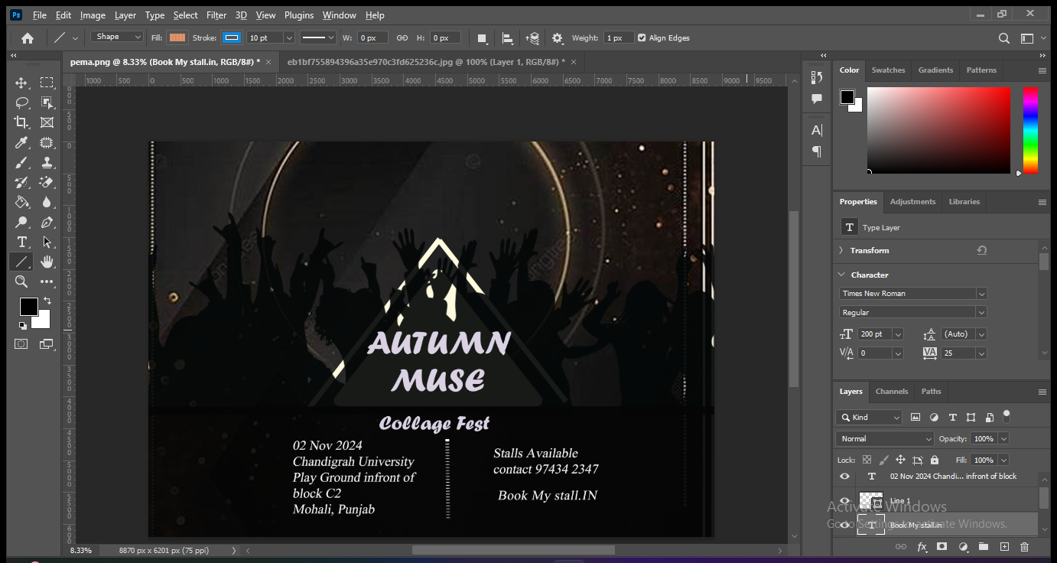

1. Learning Outcomes
2. **Image Editing and Retouching Skills**

* Understand how to make basic to advanced adjustments to photos, such as exposure, contrast, color balance, and saturation.
* Learn how to remove unwanted objects, retouch skin, and perform photo corrections.
* Master cloning, healing, and content-aware tools to enhance and refine images.

1. **Understanding Layers and Masking**

* Become proficient in using layers to organize and stack multiple elements, making complex designs easier to manage.
* Learn masking techniques to make non-destructive edits, apply filters selectively, and create complex compositions.

1. **Typography and Text Effects**

* Develop skills in adding, formatting, and customizing text for digital media.
* Learn to apply creative text effects, such as shadows, textures, and 3D effects, to enhance visual appeal.

1. **Problem-Solving:** Built skills in troubleshooting design challenges, such as achieving visual balance and managing text readability against complex backgrounds.
2. Challenges Faced and Solutions

Challenge 1: Color Harmony o Description: Finding the right color palette to match the designer’s personal brand and style.

* Solution: Experimented with different color schemes and used online color tools to achieve a cohesive look.

• Challenge 2: Layer Organization o Description: Managing multiple layers in Photoshop became challenging as more elements were added.

* Solution: Grouped related layers, named each layer clearly, and used folders to keep the workspace organized.

• Challenge 3: Text Readability o Description: Ensuring text was readable over complex backgrounds.

* Solution: Used contrasting colors, drop shadows, or semi-transparent overlays behind the text to improve readability.

1. Conclusion and Future Enhancements

Conclusion:

* Summarize how the project met the objectives by delivering a well-designed and visually appealing portfolio layout. The project successfully showcases the designer's skills and presents a professional online presence.

Future Enhancements:

* Add interactive elements, such as hover effects and animated transitions. Develop the design further into a full website layout with HTML/CSS.
* Create a responsive version of the design that adjusts for mobile screens.
* Add additional portfolio sections or personal projects as the designer’s work grows.

**Evaluation Grid:**

|  |  |  |  |
| --- | --- | --- | --- |
| Sr. No. | Parameters | Marks Obtained | Maximum Marks |
| 1. | Demonstration and Performance (Pre Lab Quiz) |  | 5 |
| 2. | Worksheet |  | 10 |
| 3. | Post Lab Quiz |  | 5 |